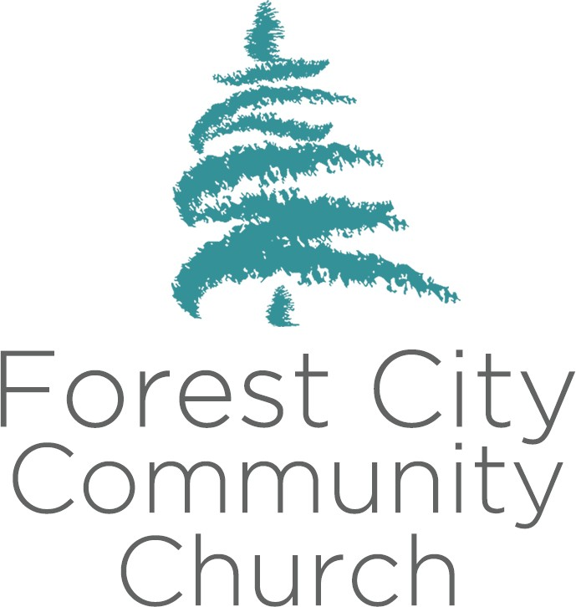

**Description**

**Adventureland Children’s Ministry Director**

*Role, Skills and Responsibilities*

The Vision of Forest City Community Church is to develop a thriving, expanding church community that honours God and serves the broader London community by helping thousands of people experience a growing relationship with Jesus Christ, and a vital place in His church family. Central to its mission is a passion to be a church that engages and reaches non-churched and de-churched people, and to help them become devoted, mature followers of Christ.  Regardless of role, each and every staff member contributes in a significant way to fulfilling the vision of FCCC.

The Adventureland Children’s Ministry Director is responsible for the oversight and direction of FCCC Children’s Ministries.

The Adventureland Children’s Ministry Director is responsible for the recruitment and development of volunteers, the distribution of materials to and scheduling of volunteers, the safe operation of Sunday morning Children’s Ministries, and the consistent reproduction of the look and feel of the FCCC Children’s Ministries.

**Skill Set –** *The Adventureland Children’s Ministry Director has:*

# Integrity of Commitment to Christ and the Vision of FCCC

* + Understands and supports the vision and values of FCCC
  + Displays biblical stewardship and tithing habits
  + Lives a life that reflects devotion and obedience to God

# Vision

* + Ability to cast vision well
  + Driving interest in furthering the FCCC vision

# Team Building

* + Ability to team build
  + Ability to read team dynamics and act accordingly *(know when to deal with stuff!)*
  + Ability to inspire and lead volunteers
  + Able to detect, discern, coach, multiply & live out the three virtues of The Ideal Teamplayer

▪ Humble

▪ People Smart

▪ Hungry

# General

* + Strengths in leadership, leadership development, team building and organizational skills
  + Growing knowledge of child development
  + A heart for family care
  + Ability to discern when intervention in difficult situations is warranted

▪ Parental discussion when children act inappropriately

▪ Volunteer discussion when volunteers need coaching or correction

▪ Others as appropriate

* + Ability to work as a member of a greater organization
  + A bias toward optimism
  + Clear communication skills
  + An understanding of details and their effect on outcomes
  + Ability to supplement own skill set with complementary skill sets found in other people

**Responsibilities –** *The Adventureland Children’s Ministry Director:*

* Gives general oversight to the children’s ministry of Forest City Community Church
* Builds teams/inspires teams and leads the execution of Sunday children’s ministries
* Meets weekly with the Preschool Director and the Adventureland Creative Arts Director
* Leads or delegates leadership for weekly children’s ministry
* Schedules and ensures volunteer teams serve on scheduled Sundays
* Participates, as appropriate, in team building and training opportunities
* Creates a ministry environment that enhances community and spiritual growth in volunteers through serving teams
* Assists in the picking and creation of curriculum
* As part of self-care, finds opportunities once a month to participate in the Sunday service